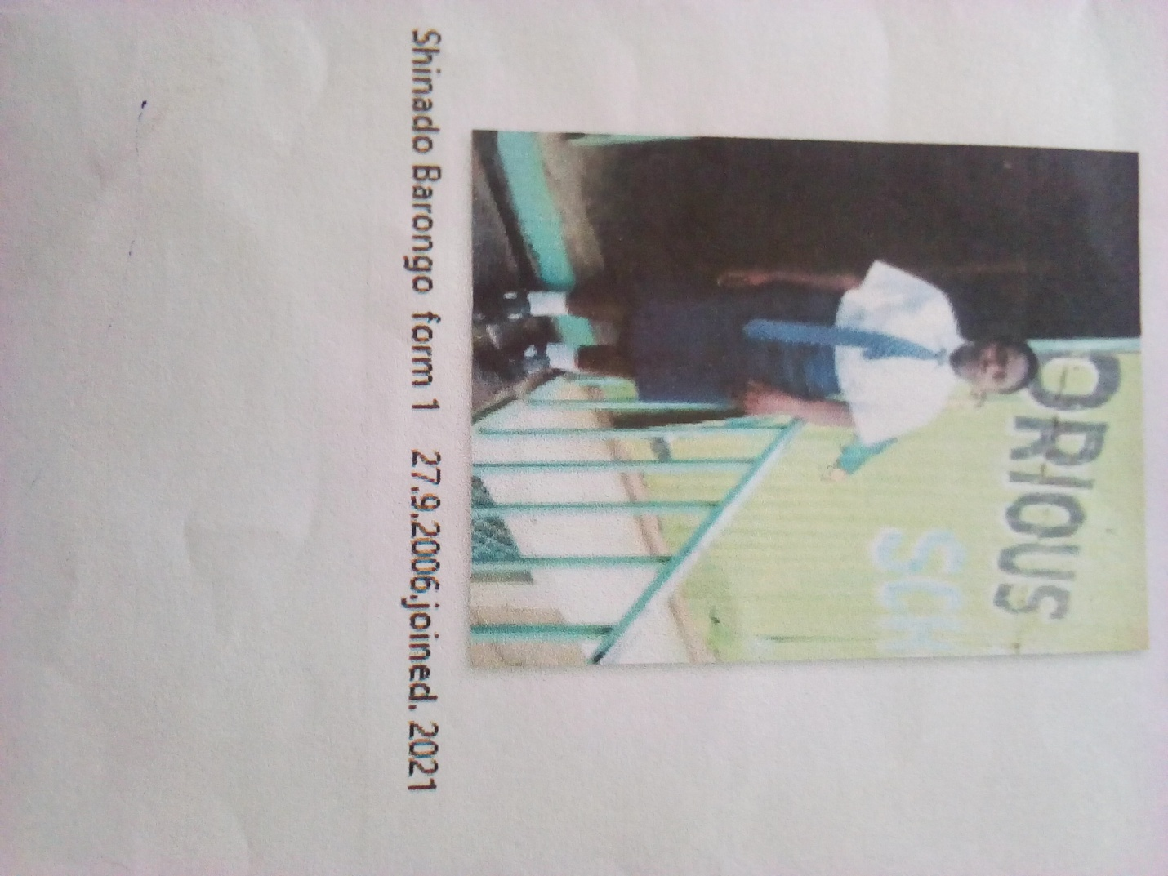

SHIDADO BARONGO FORM 1 BORN 2006 JOINED 2021
Shidado 15 years was enrolled in our school when she was 15 years old. Shidado is a bright girl staying with a drug addict mother who hardly attends to her. Came to school seeking admission in pathetic condition. Looking at her condition we empathized with her to access education. She was allowed in school; glorious is her hope for a bright future. She is promising to help others in the same state of life.
Thanks to the Director Mr. Boniface Mangeti who allowed Shidado in school. I am now learning in glorious at least I have a place I call home praying that one day God will help our school have good classes, toilets and enough learning materials. Thank you Michell and Brad for your support have really helped many in Mukuru

